INSTRUCTIONS FOR REGISTRATION OF THE AUTHOR'S PERSONAL ACCOUNT AND ELECTRONIC SUBMISSION OF ARTICLE TO THE SCIENTIFIC JOURNAL "ENGINEERING TECHNOLOGIES AND SYSTEMS"
Registration of the user in the electronic system of the scientific journal is a prerequisite for submitting an application for publication in the journal "ENGINEERING TECHNOLOGIES AND SYSTEMS".
To work with the author's profile in the system, you must first register and, following the link (http://eosj.mrsu.ru/index.php/vestnik/user/register), fill in the proposed fields
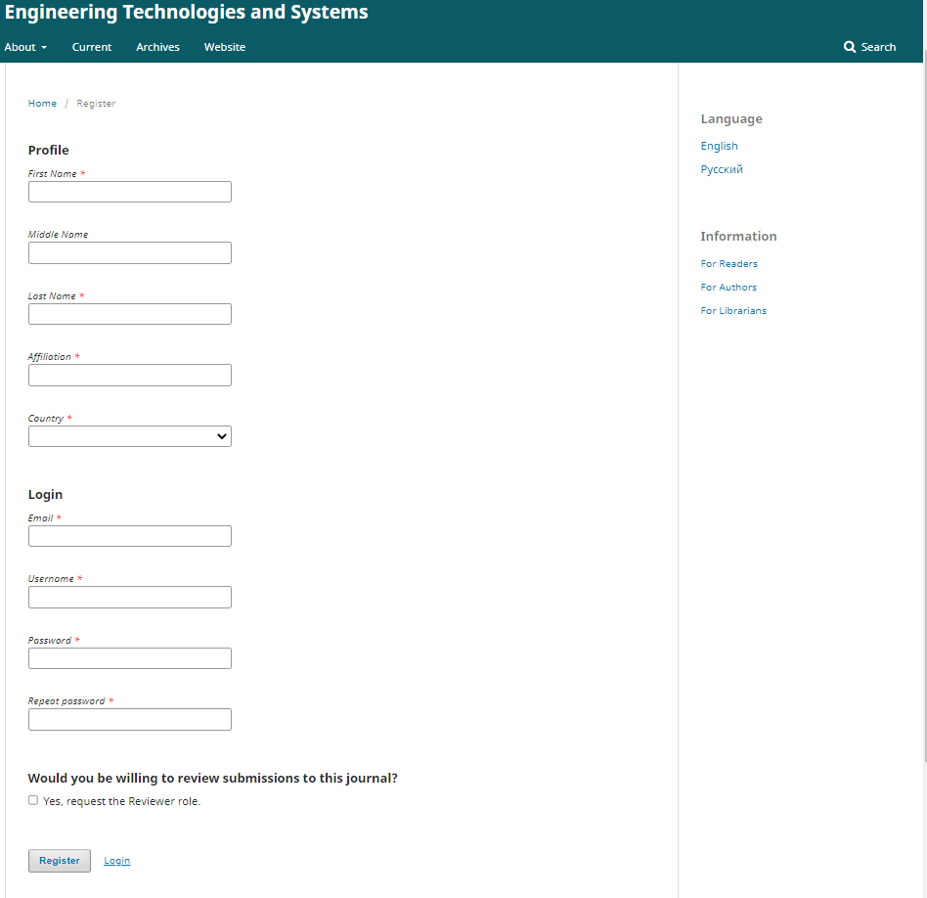
After that, when you log in, you will be taken to the toolbar as an author.
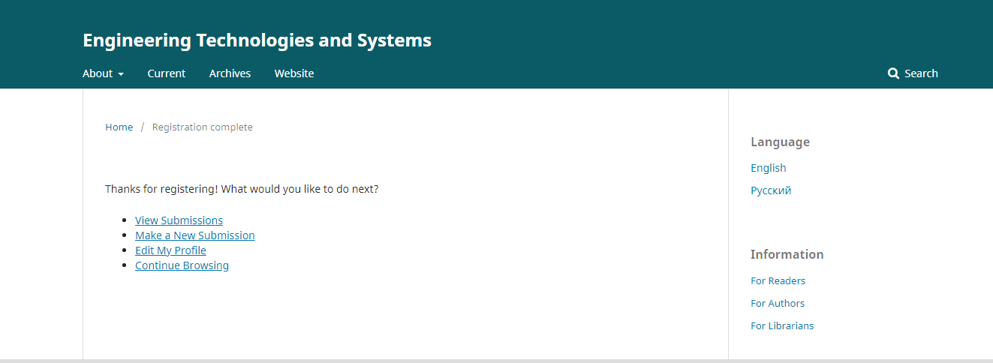
Clicking on the "Make a New Submission" link will take you to your personal account on the "Submit an Article" page. You will proceed to Step 1 of the 5-step process to upload and describe your material.
Step 1
In the Step 1, you should provide preliminary information about your material.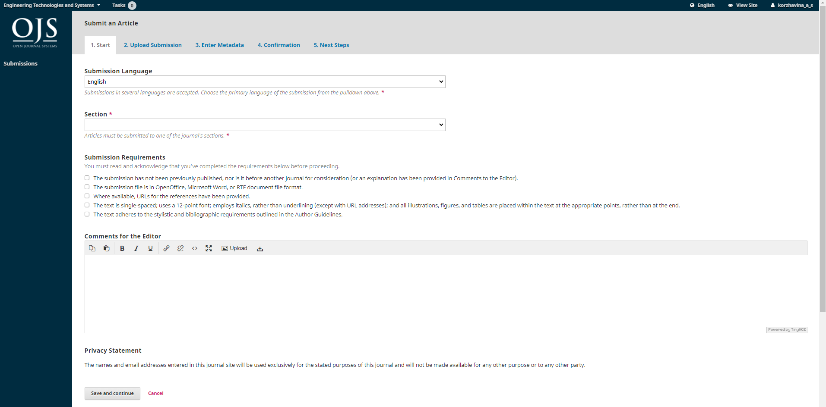
To get started, select the appropriate section for your material. If you are not sure which section is appropriate, make your best guess. Read and agree to the statements on the submission checklist, checking each requirement. Include comments for the editor, read the journal privacy statement, and then click "Save and continue" to proceed to Step 2.
Step 2
Step 2 will open a window that allows you to upload your material file. The first thing you should do is select the article component. This will let the system know if the file is the basis of a manuscript, image, dataset, etc. This should be done before the file is uploaded.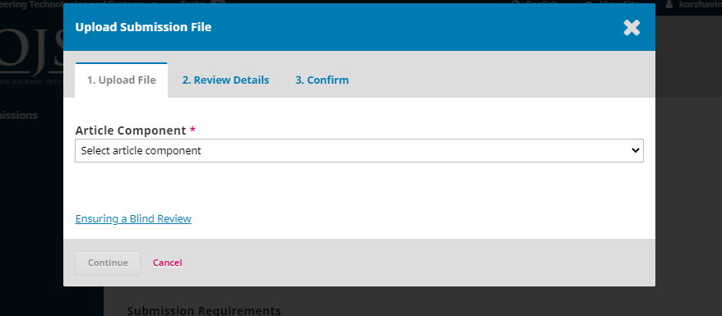
Once you have selected the article component, you can upload your first file. It is important to note that you can only upload one file at a time. Additional files may be downloaded later in the process. Typically, this first file will be the basis of your manuscript.
Warning! If you get an error "Incorrect file size" when uploading a file, you need to:
1. Use the file compression service (https://www.wecompress.com/ru/) and attach the compressed version of the file.
You can send the original file (uncompressed) to the journal e-mail (vestnik_mrsu@mail.ru) with an appropriate explanation ("Compressed file submitted to the E-Submission, we send the original").
Click the "Continue" button after downloading the file.
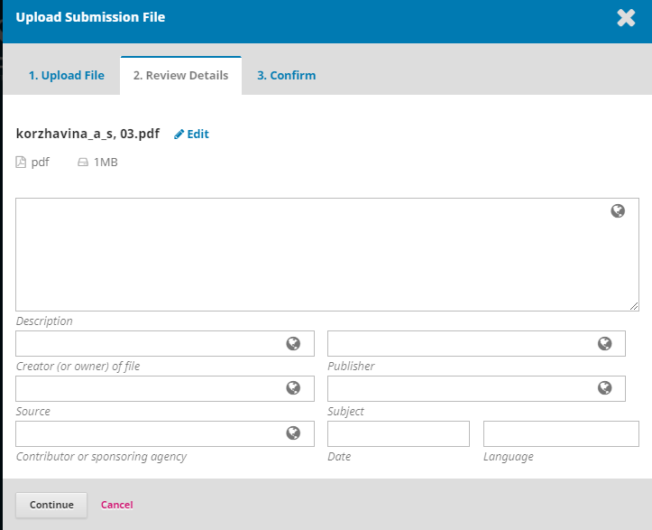
Once the file is uploaded, you will be prompted to view the file name. Use the "Edit" link to make any changes. Click the "Continue" button. You can then repeat the process of uploading additional files (such as a data set or an image). When you are finished uploading all your files, click "Finish". The material upload window will be closed.
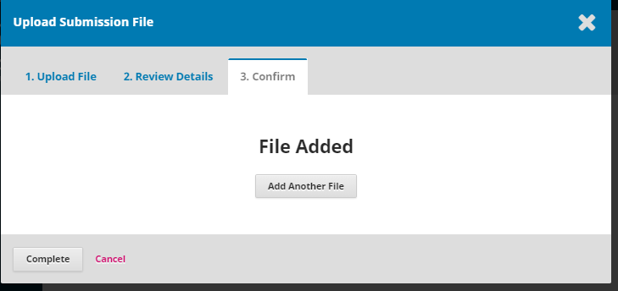
You will return to the Submit Article screen, where you will see your uploaded files. If you need to make changes, expand the blue arrow to the left of your file and make changes using the Edit link. 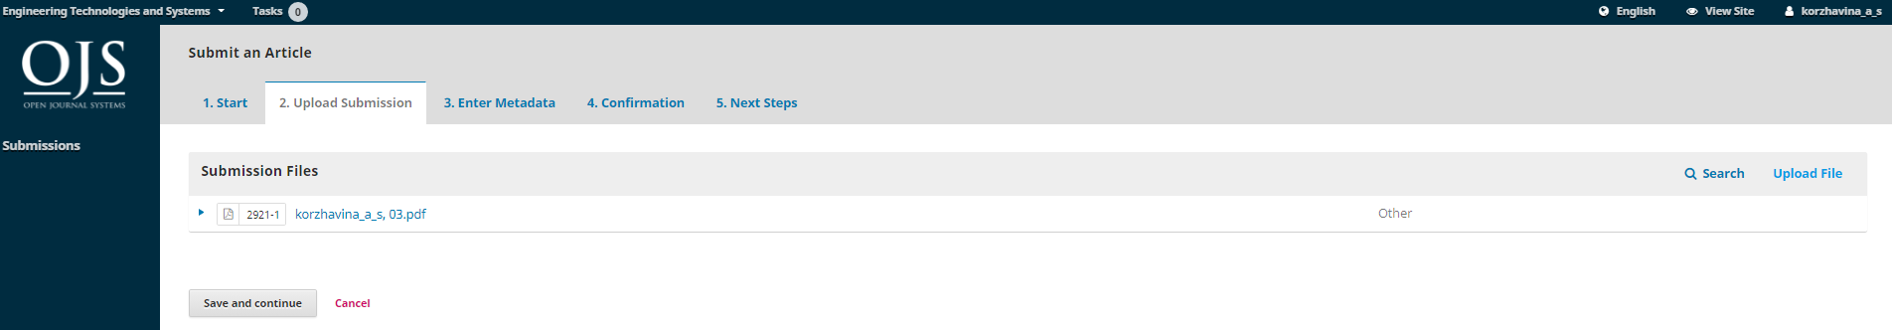
Click the "Save and continue" button to go to step 3.
Step 3
Step 3 asks you to add additional information about the piece, including the title of the piece (broken down into a prefix, title, and sub-title), an abstract, and additional contributors.
You can add other contributors (e.g., co-authors) by clicking the "Add Contributor" link. A new window will open with fields for entering information.

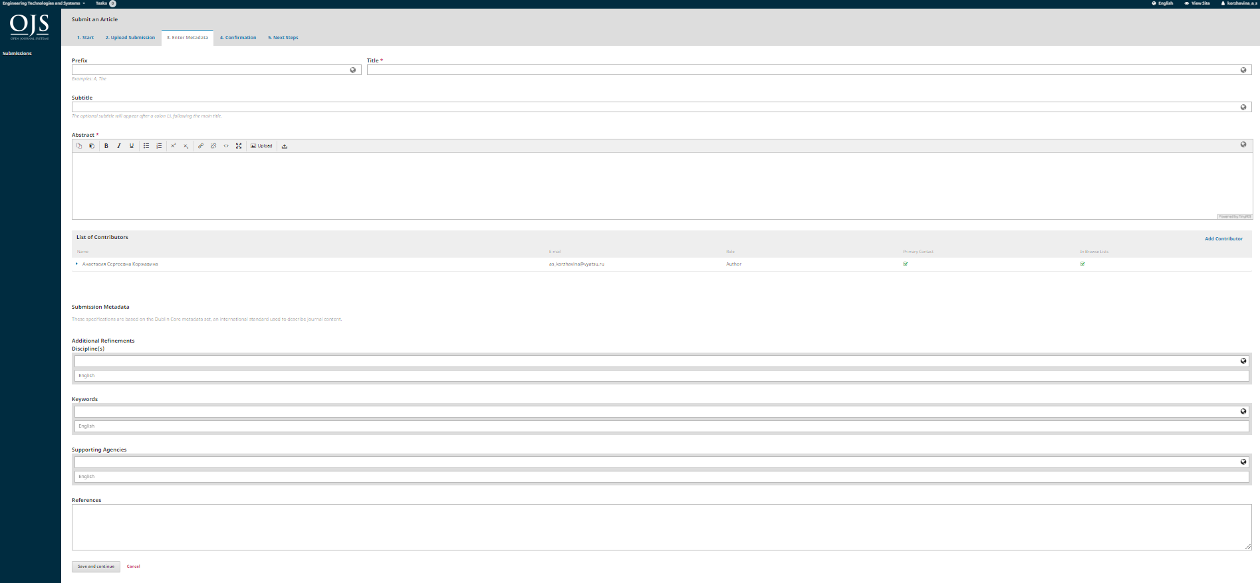
Click "Save" to have the new member appear on the Author Lists page.
You may see additional fields to fill in, such as keywords.
To enter a keyword, simply type the word or phrase and press enter. The word or phrase will be formatted as a keyword. Click "Save and Continue" to go to the next step.
Step 4
In step 4, you will be asked to confirm that you are ready to finish your submission. Click Finish Submitting.

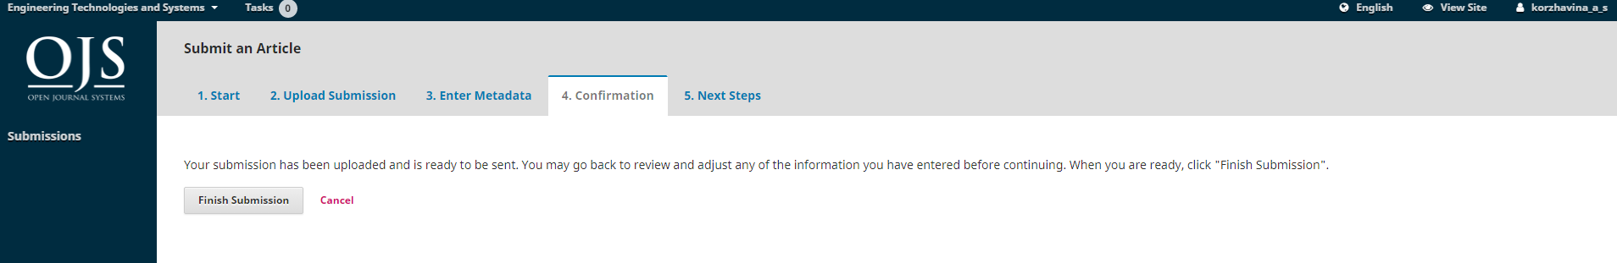
A window will appear asking you to confirm that you are ready to submit the article. Click "OK".
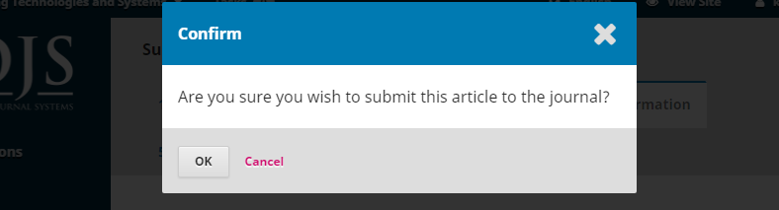
Step 5
The submission is complete! The editor has been notified of your new article. At this point, you can click on the links:
- Review this submission;
- Create a new submission;
- Return to dashboard.
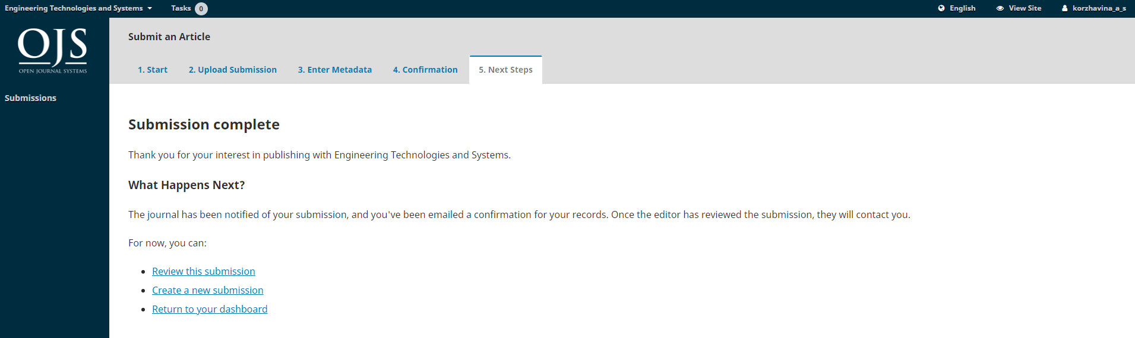

My Account
Your submission is in your personal account. You can see that it is in the submission process.
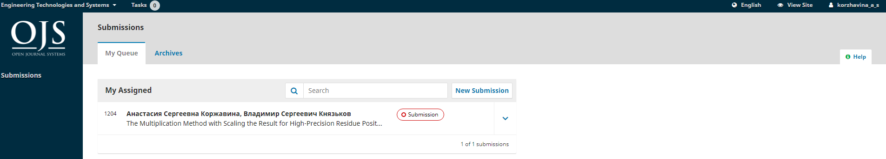
In the next few days, it will move to the Review stage and, if the material is accepted, it will move on to the Literary Editing and Publishing stage before publication.

